Email Correspondence from tenants to MDC ‘Himatangi Beach Holiday Park’ via email requesting approval of fees.
Email received 25th September 2025.
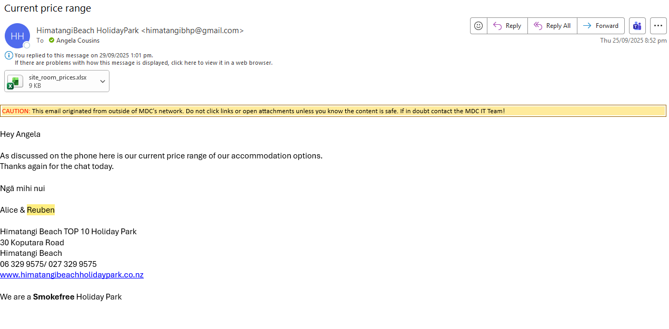
Spreadsheet attachment ‘site room prices’ from above email copied below:
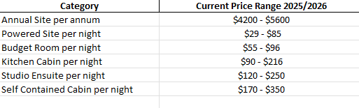

Email Correspondence from MDC to the tenants ‘Himatangi Beach Holiday Park’ that the fees have been approved by way of delegated authority.
Email sent 6th October 2025.
